**BUG REPORT**

**Defect** **id :** B _001

**Defect** **Name :** TC_Password field

**Test case ID :** TC_055

**Module** **name :** Sign in

**Severity** **:**  Low

**Priority** **:** High

**Summary / Objective :** To check whether the password field should not accept space between two characters

**Steps to reproduce / Description :**

**Pre- requisite** :

1. YourLogo Webpage should open in default browser 2. Create an Account page should be open 3. Internet connectivity should be available
2. Steps to reproduce :-
3. Go to yourlogo website
4. Navigate to Password field
5. Enter password

**Actual Result :** password field is accepting spaces between characters

**Expected Result :** password field should not accept the space between the characters.

Note/observations:-

1. Please refer the attached screenshot

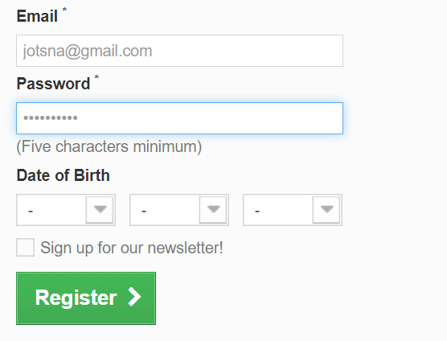

**Defect** **id :**  B_002

**Defect** **Name :** TC_SendToFriend__name_num

**Test case ID :** TC_132

**Module** **name : Women**

**Severity** **:**  Low

**Priority** **:** High

**Summary / Objective :** To verify that Name field should not accept numbers

**Steps to reproduce / Description :**

**Pre- requisite** :

1. YourLogo Webpage should open in default browser 2. Women Option should be open 3. Internet connectivity should be available
2. Steps to reproduce :-
3. Click on SendToFriend
4. Click on name field
5. Type any combinations of numbers

**Actual Result :** Name field is accepting numbers

**Expected Result :** Name field should not accept numbers

Note/observations:-

1. Please refer the attached screenshot

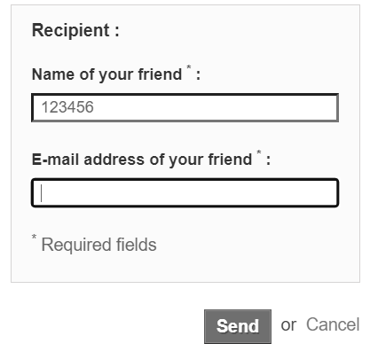

**Defect** **id :**  B_003

**Defect** **Name :** Tc_SendToFriend__name_Special Symbols

**Test case ID :** TC_133

**Module** **name : Women**

**Severity** **:**  Low

**Priority** **:** High

**Summary / Objective :** To verify that Name field should not accept Special Symbols

**Steps to reproduce / Description :**

**Pre- requisite** :

1. YourLogo Webpage should open in default browser 2. Women Option should be open 3. Internet connectivity should be available
2. Steps to reproduce :-

1)Click on SendToFriend

2)Click on name field

3) type special symbols

**Actual Result :** Name field should not accept Special Symbols

**Expected Result :** Name field should not accept Special Symbols

Note/observations:-

1. Please refer the attached screenshot

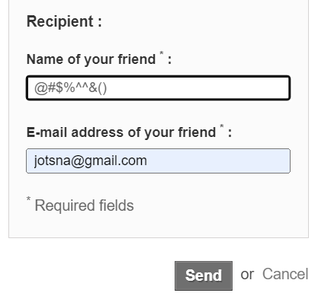

**Defect** **id :** B _004

**Defect** **Name :** Tc_SendToFriend__email_Valid

**Test case ID :** TC_143

**Module** **name :** Women

**Severity** **:**  Low

**Priority** **:** High

**Summary / Objective :** To verify that in Email field should not accept invalid email id

**Steps to reproduce / Description :**

**Pre- requisite** :

1.YourLogo Webpage should open in default browser 2. Women Option should be open 3. Internet connectivity should be available

1. Steps to reproduce :-

1)Go to sendToFriend website

2)click on email field

3)type any invalid email id

**Actual Result :** Email field is accepting invalid email id

**Expected Result :** Email field should not accept invalid email id

Note/observations:-

1.Please refer the attached screenshot

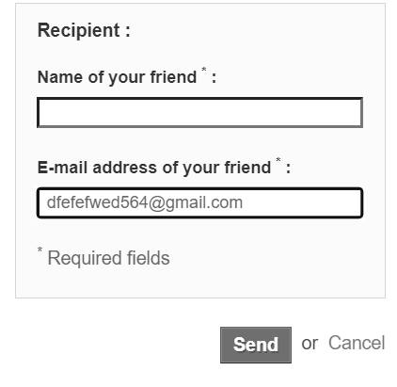

**Defect** **id :** B _005

**Defect** **Name :** Tc_YourAdd_Name_space

**Test case ID :** TC_212

**Module** **name :** My Account

**Severity** **:**  Low

**Priority** **:** High

**Summary / Objective :** To check that name field should not accept space between characters

**Steps to reproduce / Description :**

**Pre- requisite** :

1.YourLogo Webpage should open in default browser 2. Create an Account page should be open 3. Internet connectivity should be available

Steps to reproduce :-

1)click on name field

2) Enter your name by giving space between characters.

**Actual Result :** Space between characters is accepted

**Expected Result** : Space between characters should not be accepted

Note/observations:-

1.Please refer the attached screenshot

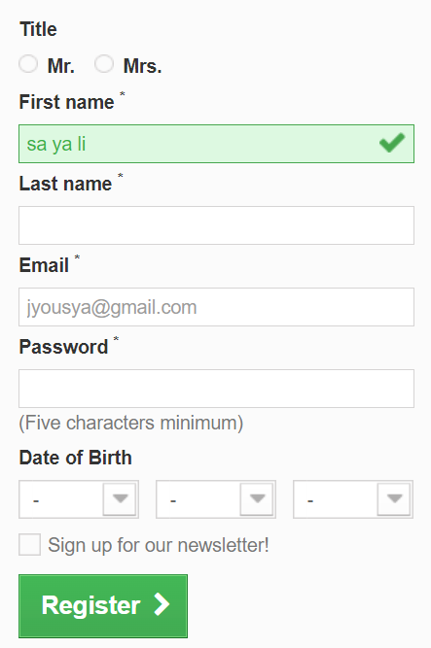

**Defect** **id :** B _006

**Defect** **Name :** Tc_YourAdd_Lastname_space

**Test case ID :** TC_218

**Module** **name :** My account

**Severity** **:**  Low

**Priority** **:** High

**Summary / Objective :** To check that Lastname field should not accept space between characters

**Steps to reproduce / Description :**

**Pre- requisite** :

1.YourLogo Webpage should open in default browser 2. Your Address page should be open 3. Internet connectivity should be available

Steps to reproduce :-

1. click on Lastname field 2. Enter your Lastname by giving space between characters.

**Actual Result :** Space between characters is accepted

**Expected Result :** Space between characters should not be accepted

Note/observations:-

1.Please refer the attached screenshot

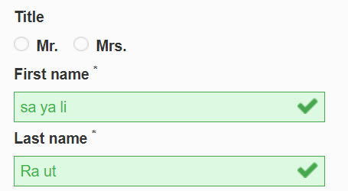

**Defect** **id :** B _007

**Defect** **Name :** Tc_YourAdd_Company_Num

**Test case ID :** TC_222

**Module** **name :** My account

**Severity** **:**  Low

**Priority** **:** High

**Summary / Objective :** To check that company field should not accept Numbers only

**Steps to reproduce / Description :**

**Pre- requisite** :

1.YourLogo Webpage should open in default browser 2. Your Address page should be open

3. Internet connectivity should be available

Steps to reproduce :-

1. click on Company field 2. Enter Company name as combination of Numbers

**Actual Result :** company field is accepting Numbers only

**Expected Result :** company field should not accept Numbers only

**Defect** **id :** B _008

**Defect** **Name :** Tc_YourAdd_Company_special symbols

**Test case ID :** TC_223

**Module** **name :** My account

**Severity** **:**  Low

**Priority** **:** High

**Summary / Objective :** To check that company field should not accept special symbols only

**Steps to reproduce / Description :**

**Pre- requisite** :

1.YourLogo Webpage should open in default browser 2. Your Address page should be open

3. Internet connectivity should be available

Steps to reproduce :-

1. click on Company field
2. Enter Company name as combination of special symbols

**Actual Result :** company field is accepting special symbols only

**Expected Result :** company field should not accept special symbols only

**Defect** **id :** B _009

**Defect** **Name :** Tc_YourAdd_address_num

**Test case ID : TC_227**

**Module** **name :** My account

**Severity** **:**  Low

**Priority** **:** High

**Summary / Objective :** To check that Address field should not accept Number only

**Steps to reproduce / Description :**

**Pre- requisite** :

1.YourLogo Webpage should open in default browser 2. Your Address page should be open

3. Internet connectivity should be available

Steps to reproduce :-

1.click on address field

2. Enter any combination of Number only

**Actual Result :** Address field is accepting Number only

**Expected Result :** Address field should not accept Number only